Brief Profile
Dr. Jayaprakashnarayana Gade
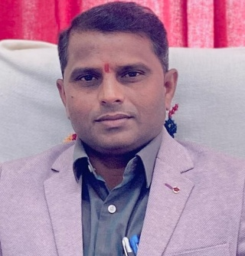
Dr. Jayaprakashnarayana Gade is a distinguished academic and Tourism Professional with expertise in Water-based Tourism, Tourism Marketing, Airport Management, Tribal Tourism, and Travel Agency Management. He is currently serving as an Assistant Professor in the Department of Tourism Management at the Indira Gandhi National Tribal University (IGNTU), Amarkantak. He has previously worked for Ten years as an Assistant Professor (C) in the Department of Business Management at Mahatma Gandhi University, Nalgonda, Telangana, and has over three years of industry experience with Sabharwal Tours and the Department of Tourism, Government of Andhra Pradesh.
He has a strong research background with 10 papers in Scopus and UGC-CARE journals, 25 papers in refereed journals, 7 book chapters and 5 authored/edited books. He has delivered 13 invited lectures, presented research Papers at national and international conferences and currently supervises four Ph.D. scholars.
Dr. Gade holds active academic memberships, including a Lifetime Membership in the Indian Tourism and Hospitality Congress and is a published innovator with a patent titled “ATITHI Feedback System – Hotel Management.” He has received notable honours including the Governor Award (Scouts & Guides) and the Telangana State Tourism Award (2023).
He has organized several national seminars, workshops and training programs and has contributed extensively to university administration through roles such as NSS Programme Officer, Assistant Proctor, BOS Member, Warden and Coordinator for various academic bodies.

